1. 
2. 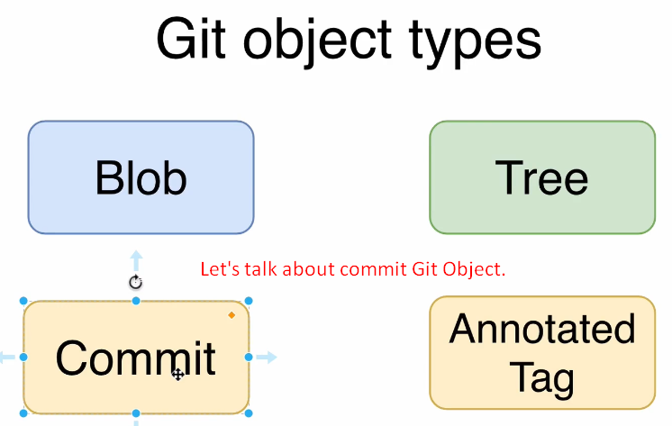
3. 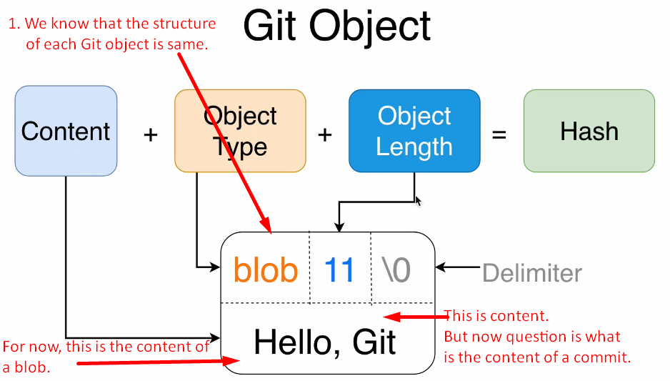
4. **Content of a Commit**:
   1. Parent is optional.
   2. 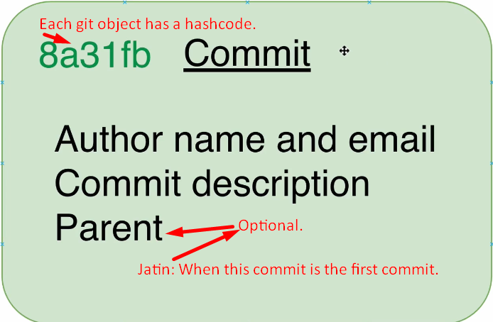
5. **What is the purpose of a commit**:
   1. Commit helps to save the different versions of a project or we can say “**different snapshots**”.
   2. Using a specific commit, we can checkout a specific version of the project.
6. 
   1. 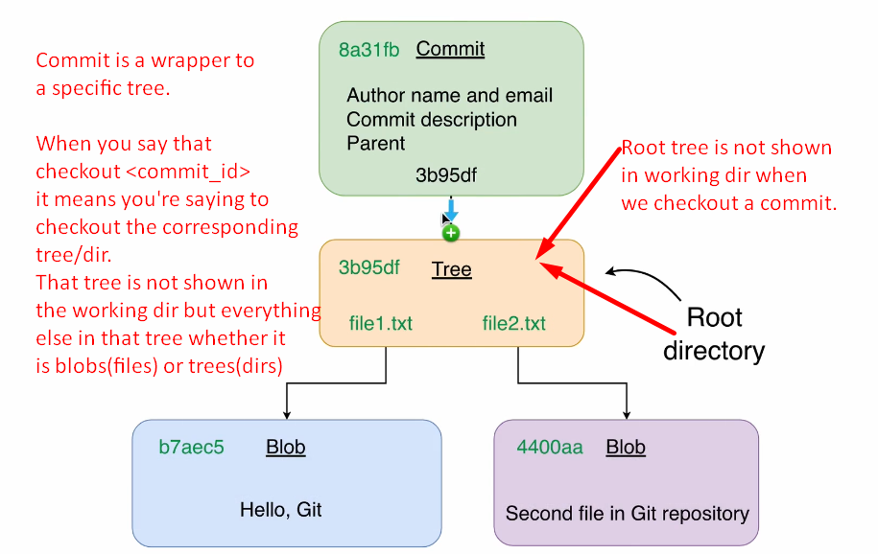
   2. 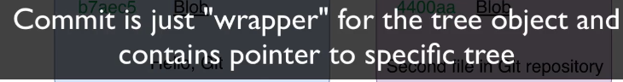  
      The above means that commit is wrapper for the tree object. But how? Commit contains hashcode (pointer) of a tree which is called **Root Tree**.
   3. 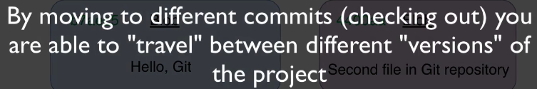
   4. 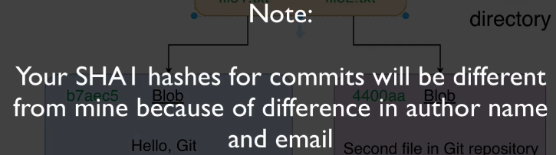
7. **Terms**:
   1. **Snapshots = Versions**